Chapter 14, Solution 1.

Find the transfer function v_{o}/v_{i} of the RC circuit in Fig. 14.68. Express it using ω₀ = 1/(RC).

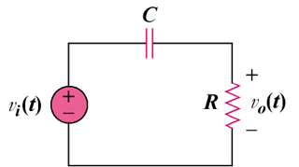

Figure 14.68
For Prob. 14.1.

Solution

, where

This is a highpass filter. The frequency response is the same as that for P.P.14.1 except that . Thus, the sketches of H and are shown below.
0
1
0.7071
₀ = 1/RC

H
0
90
45
₀ = 1/RC

